- Please follow this connection :

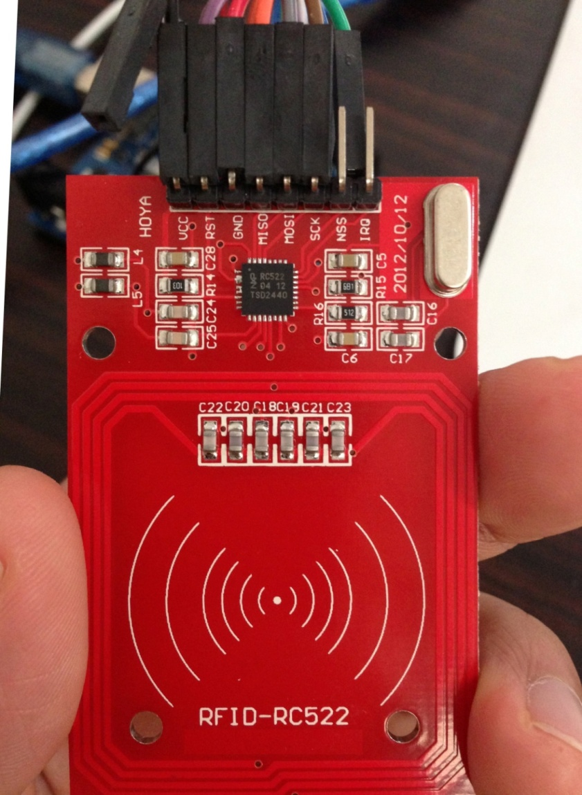
RFID arduino Uno R3
VCC <----------------------------> 3.3V
RST <----------------------------> Digital pin 5
GND <----------------------------> GND
MISO <----------------------------> Digital pin 12
MOSI <----------------------------> Digital pin 11
SCK <----------------------------> Digital pin 13
NSS <----------------------------> Digital pin 10

RFID arduino mega 2560
VCC <----------------------------> 3.3V
RST <----------------------------> Digital pin 5
GND <----------------------------> GND
MISO <----------------------------> Digital pin 50
MOSI <----------------------------> Digital pin 51
SCK <----------------------------> Digital pin 52
NSS <----------------------------> Digital pin 53

for mega 2560 , please revise “const int chipSelectPin = 10 to --> const int chipSelectPin = 53; as mega 2560 uses port 53

Please notice not to connect them wrong , otherwise , it is possible to burn down the board.

- Please use Arduino IDE to upload the sample code to your Uno R3 board and mega 2560 . they might have different port , please notice this .
.
rfid_code_test_uno r3 is in the same folder.
Or rfid_code_test for mega 2560.ino

- Please open the Serial Monitor from Arduino IDE , and set the baud rate to “57600” .
And then when you put the tag onto the reader , you can see below :

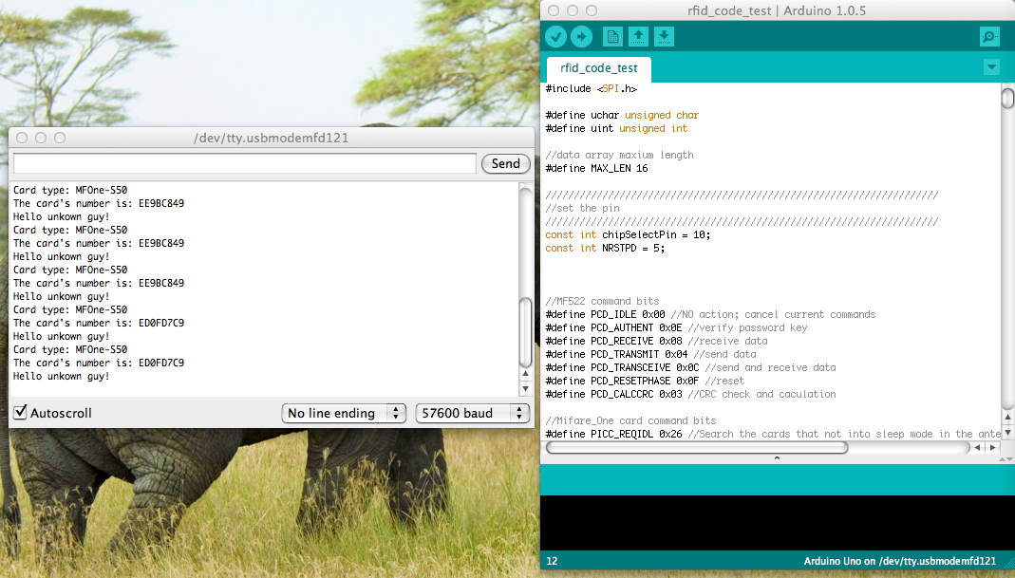

Then it is done !

